Increasing attendance with parent messages
Supportive ‘how-to’ guide for schools
Catching up on lost learning during school closures will only be possible with good school attendance, but attendance rates remain below pre-pandemic levels.
This guide is designed to help teachers and school leaders improve attendance among persistently absent students by sending evidence-based messages to parents. The messages were developed and tested by Bristol City Council in 2020 in partnership with the Behavioural Insights Team (BIT) and have been updated in 2022 for the current context.
Why send parents messages about their child’s attendance?
Parents play a critical role in their children’s school attendance. However, research shows that parents tend to underestimate the total number of days their child has been absent by around 6 days across the year.
Informing parents about their child’s attendance has been shown to work in multiple contexts:
- A recent study with Bristol City Council found that messaging parents of children with attendance below 95% increased good attendance rates by 4 percentage points. This approach also increased attendance during the early stages of the pandemic.
- A US study with 28,000 students, found that messages about the number of days a child had missed reduced absenteeism by an average of 1.1 days a year, and reduced persistent absenteeism by 10%.
More details on both these studies can be found in Section 4.
How to use this guide
This guide has four sections:
- What to say to parents
- Template messages
- How to implement this in your school
- Evidence from Bristol and the US

1. What to say to parents
Based on the evidence, the ‘active ingredients’ of effective parent messages on attendance are:
- Specifying the number of days missed (not a percentage attendance rate). Research shows that parents systematically underestimate the number of days their children have missed, and also struggle to interpret attendance expressed as percentages (e.g. ‘90% attendance’ sounds positive but actually reflects 15 days of school missed over the year). Specifying the exact number of days missed makes it easier for parents to understand.
- Reminders about the importance of attendance and parents’ role in it. Research shows that it is important to make the connection between attendance and attainment, and to make parents feel like they can do something to improve the situation.
Effective parent message are also:
- Personalised (with parent/student names). Research shows that people are more likely to take notice of communications that are personalised to them. It is therefore important to include parent and student names.
- Timely (at the start of each term). Research suggests that people are more motivated to adopt new behaviours at moments of change, such as a new school term (i.e., every 6 to 8 weeks). This is called the ‘fresh start effect’.
- Short. Adding extra information is likely to detract from the core message and may reduce impact.
Re-using similar messages at the start of each term does not appear to reduce impact.
A note on COVID-19
Most of the research informing this guidance was conducted before the pandemic. It is therefore important for schools to use their professional judgement to assess COVID-related sensitivities and adjust the messages accordingly.
However, be careful not to add too much additional information. Feedback from academics and school leaders suggests that adding empathetic language might be useful for long-term relationships with families, but may also distract from the ‘active ingredients’.

2. Template messages
Parent message highlighting the ‘active ingredients’:
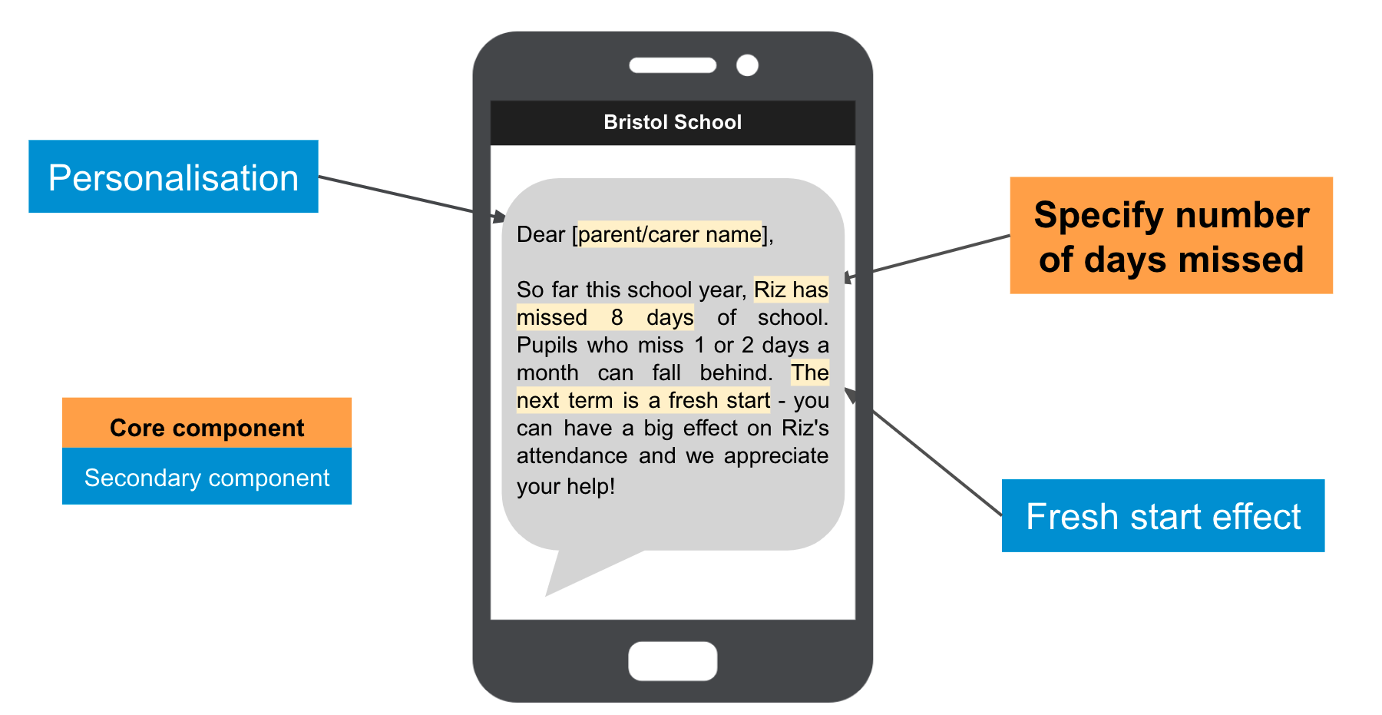
Below are three template messages. You may use these as they are or adapt them for your context and the latest COVID situation.

Template 1:
Dear {Parent Name}. Last term, {Student Name} missed {Number of days missed in previous term} days of school. Pupils who miss 1 or 2 days a month can fall behind. The next term is a fresh start - you can have a big effect on {Student Name}'s attendance and we appreciate your help!

Template 2:
Dear {Parent Name}. Last term, {Student Name} missed {Number of days missed in previous term} days of school. Absences can have lasting effects on learning. This term is a fresh start and we appreciate your support in getting {Student Name} to school every day!

Template 3:
Dear {Parent Name}. Last term, {Student Name} missed {Number of days missed in previous term} days of school. School attendance is more important than ever, and every day matters. This term is a fresh start and we appreciate your support in getting {Student Name} to school every day!

3. How to implement this in your school
Below is a step-by-step process for sending personalised parent messages at your school.

Step 1 - Identify students who had attendance below your target threshold (e.g., 95%) in the previous term
At the start of each term, generate a spreadsheet with each student’s name, their attendance rate for the previous term (6-8 week period) and the number of days they missed in that period. Filter this list to include just those students who had an attendance rate below your target threshold - this is your target group.

Step 2 - Remove any students who had extenuating circumstances
Remove any students that had extenuating circumstances explaining their low attendance. For example, if a student was ill, had tested positive for COVID19 or was isolating due to COVID. Schools are best placed to judge whether it would be appropriate to send a message.

Step 3 - Generate the list of personalised messages
Run a ‘mail merge’ with the template messages in section 1 and your list of target students. This will generate a list of personalised text messages for each student in the target group. You can adapt the templates for your context - if you do so, we strongly recommend you still specify the number of days the child has missed (and avoid using percentage attendance rates, which parents can find confusing).

Step 4 - Send the messages
Send the personalised messages to parents using your usual channels. For many schools, this will be a text message. You can use online tools like Firetext or Notify (or other SMS automation tools) to automate personalised message delivery. If possible, send the message in the first few days of term.

Step 5 - Repeat at the start of each term
Repeat Steps 1-4 at the beginning of each term, or at regular intervals when you feel like a text reminder would be useful.

Text message automation
You can use online tools like Firetext or Notify (or other SMS automation tools) to automate personalised message delivery. If possible, send the message in the first few days of term.

4. Evidence from Bristol and the US

3.1. Results from Bristol
In partnership with Bristol City Council, the parent messages in Section 2 were tested in a randomised controlled trial in Bristol with 9,254 students across 22 schools. Parents in the treatment group received a message if their child’s attendance was below 95% in the previous term, and the child had no extenuating circumstances that explained their absence. Most schools texted parents, but some used emails or other communications.
The headline result was that the approach boosted the proportion of students keeping good attendance records by 4 percentage points.

Full results

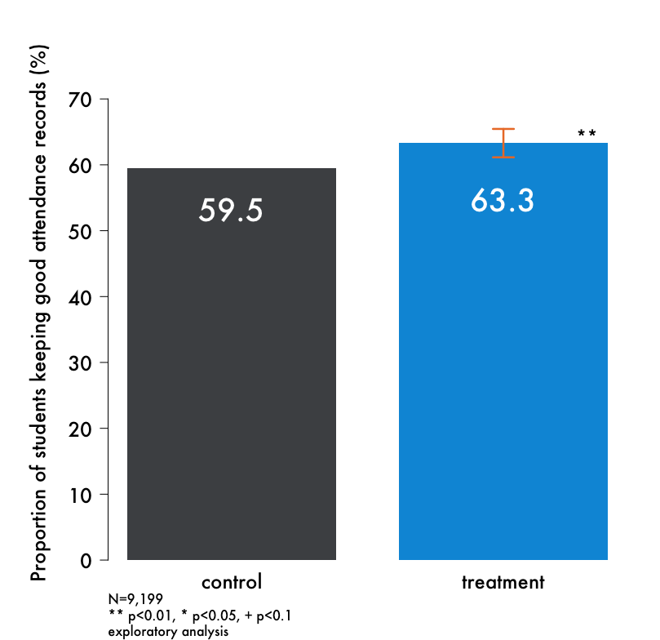
Proportion of Students with Good Attendance
The approach boosted the proportion of students keeping good attendance records (95%+) by 4 percentage points (59.5% to 63.3%), and this positive result is unlikely to have occurred by chance.

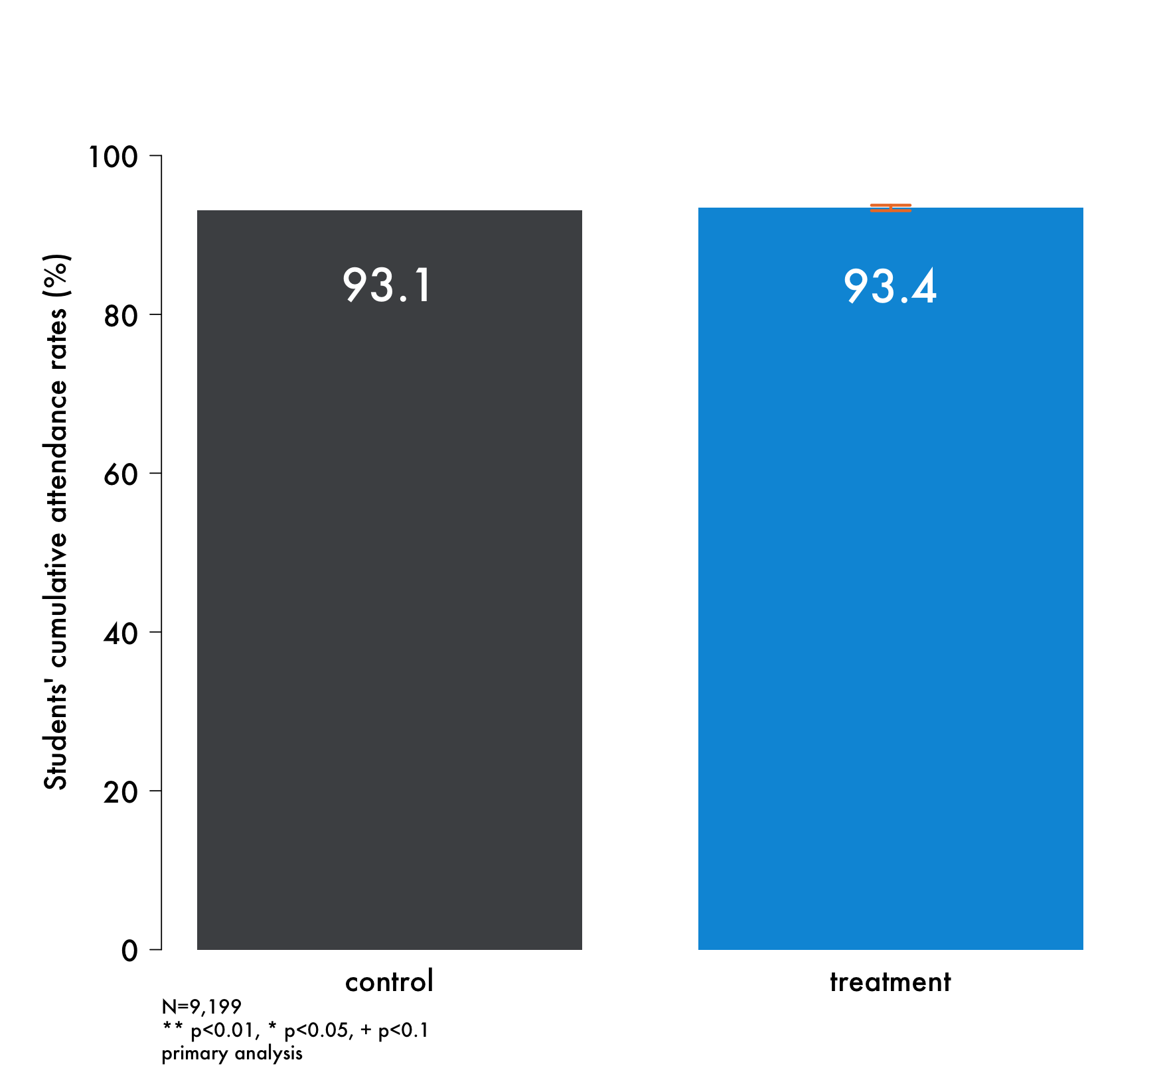
Overall Attendance Rates
The overall student attendance rate was slightly higher in the treatment group (93.4%) compared to the control group (93.1%), but this difference was not statistically significant.

Two reasons likely contributed to this: (1) attendance messages were only sent to a third of students in the treatment group, as the others had attendance above 95%, (2) the trial ended early due to COVID-19, providing less opportunity for the messages to work.

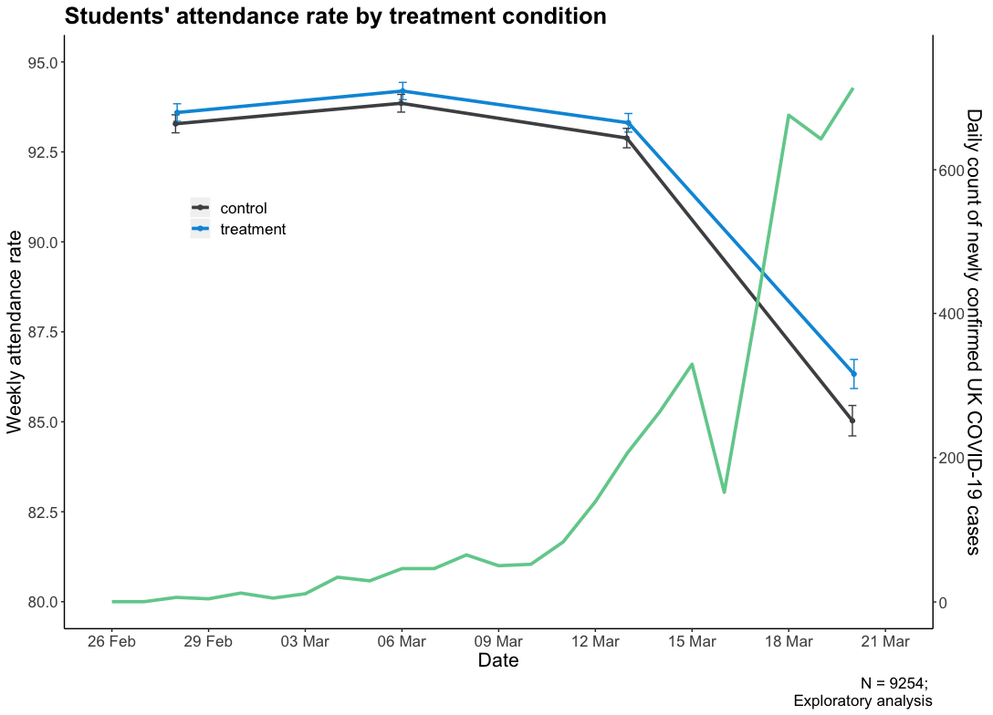
Effectiveness during the Pandemic
The messages were effective during the early stages of the COVID-19 outbreak. Compared to the control group, students in the treatment group attended school more in the run-up to closures. This positive result was also unlikely to have occurred by chance. This suggests that the messages may continue to work while COVID is an ongoing issue.

3.2. U.S. results
Researchers in the US tested three different parent messages with 28,000 families (sent by letter).
The headline result was that informing parents about the number of days missed by their child reduced absenteeism by an average of 1.1 days over the course of the year, and also reduced the likelihood of being persistently absent by 10%.

Content of the messages
Families were randomised to one of four groups.

- Reminder. Reminded parents of the importance of absences and of their ability to influence their child’s attendance.
- Total absences. Built on (a) but also told parents the total number of absences for their child.
- Relative absences. Built on (b) but also added information about how their child’s absences compared to their classmates.
- Control. This group received no additional communications beyond the normal school communications about attendance.
Examples of the messages sent are copied below.

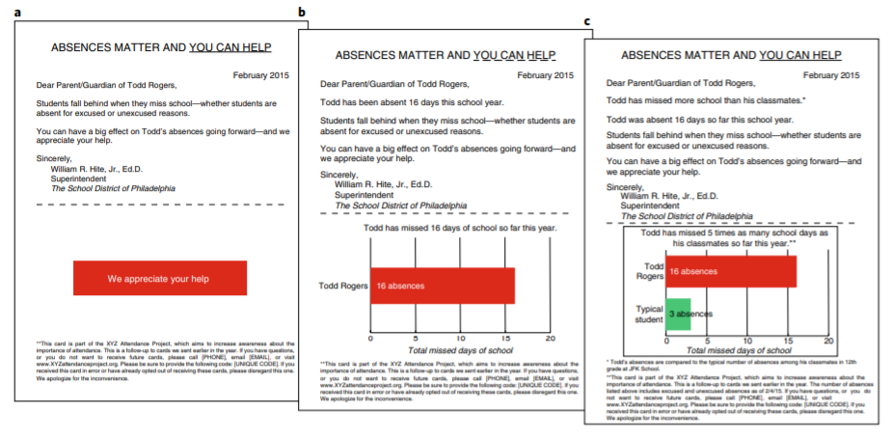

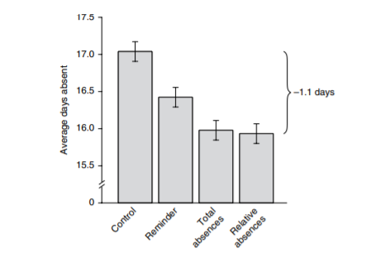
Results
The reminder alone reduced absenteeism by an average of 0.6 days over the course of the year compared to not receiving a letter. Information on the total days missed reduced absenteeism by an average of 1.1 days over the course of the year, and the likelihood of being persistently absent by 10%. There was no significant additional benefit to including information on relative absences.

For more information...
The Behavioural Insights Team are interested in hearing your feedback – if you have questions or would like to share your experiences, please get in touch with lal.chadeesingh@bi.team.

Rogers, T., Feller, A. Reducing student absences at scale by targeting parents’ misbeliefs. Nat Hum Behav 2, 335–342 (2018). https://doi.org/10.1038/s41562-018-0328-1
https://www.bi.team/blogs/improving-student-attendance-through-timely-nudges/
Rogers, T., Feller, A. Reducing student absences at scale by targeting parents’ misbeliefs. Nat Hum Behav 2, 335–342 (2018). https://doi.org/10.1038/s41562-018-0328-1
For more information on how to run a ‘mail merge’, please consult this guide.
“Good attendance” was defined in the trial as above 95%.
It should be noted that the “good attendance” analysis was exploratory, while the overall attendance rate was the pre-specified primary outcome measure.
Decisions about when pupils can go to school should be based on pupil and teacher safety.
Rogers, T., Feller, A. Reducing student absences at scale by targeting parents’ misbeliefs. Nat Hum Behav 2, 335–342 (2018). https://doi.org/10.1038/s41562-018-0328-1
Persistently absent was defined as missing more than 18 days of school over a year.

